**STEPS**

**(Student-Transferee Enrolment Processing System)**

**Class Diagram**

**Admin**

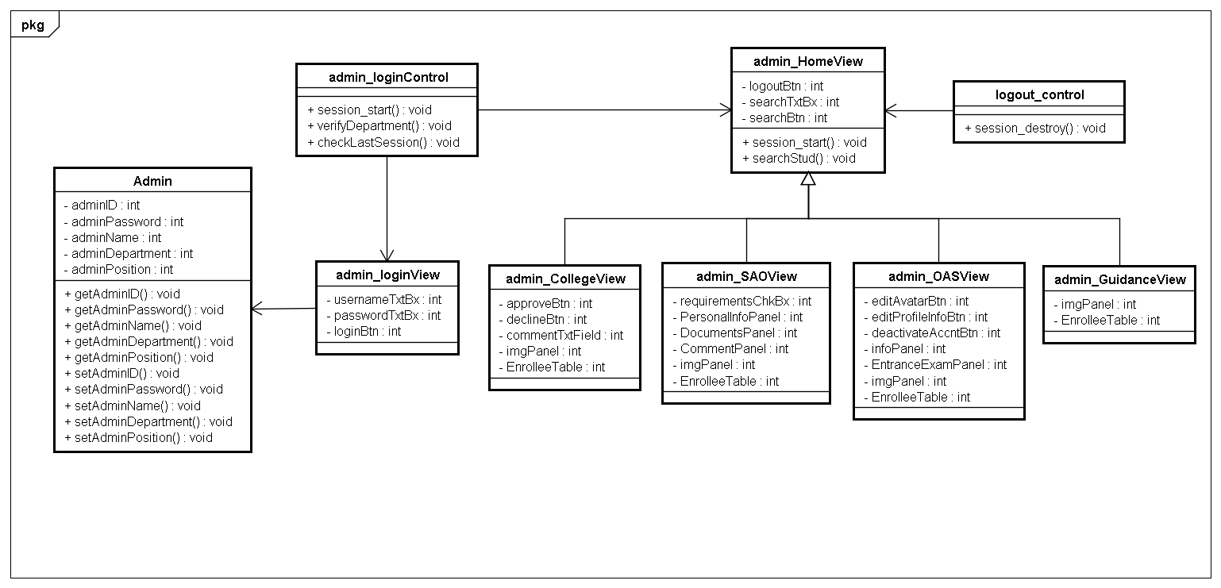**Login/Logout Class Diagram**

**Admin**

**College Class Diagram**

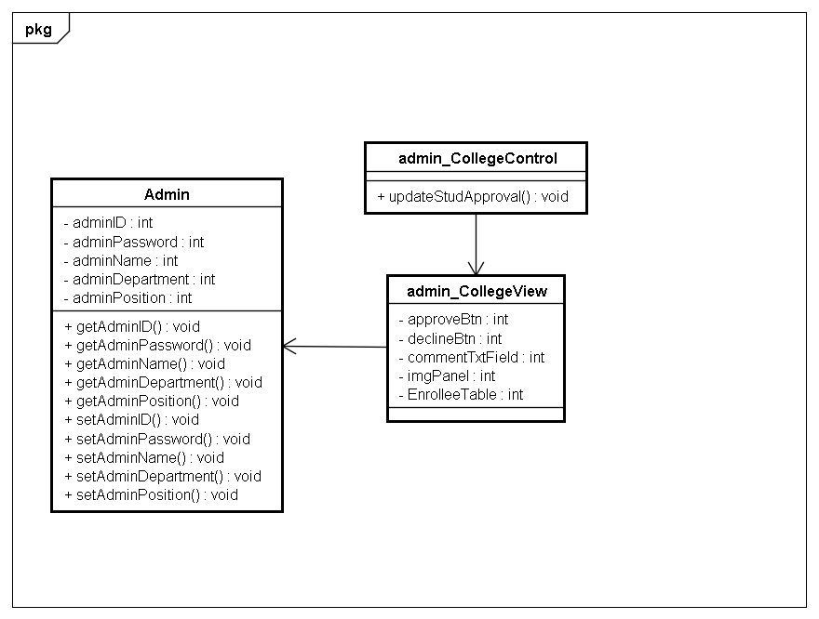

Admin

SAO Class Diagram

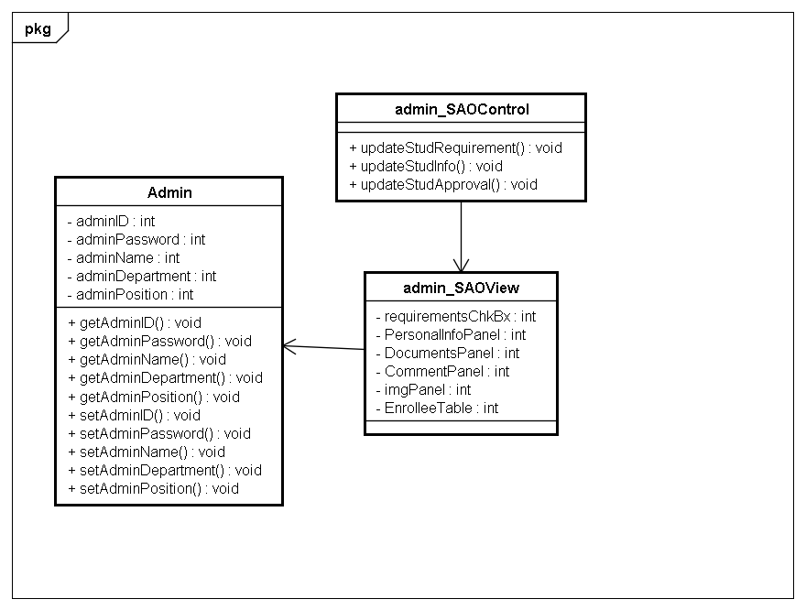

Admin

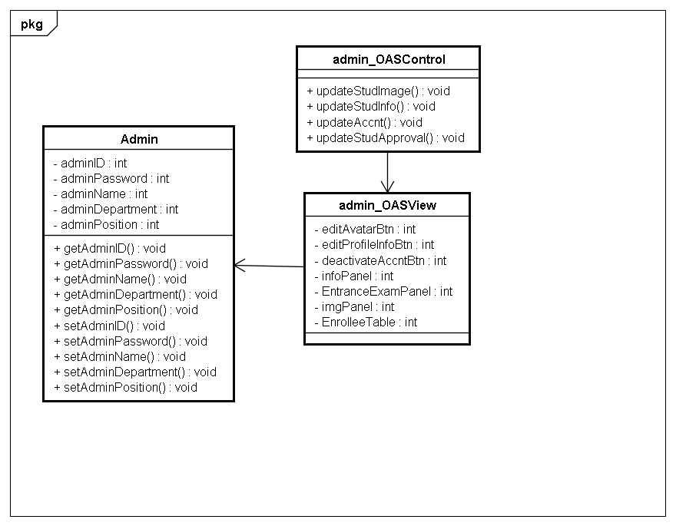OAS Class Diagram

Admin

Guidance Class Diagram

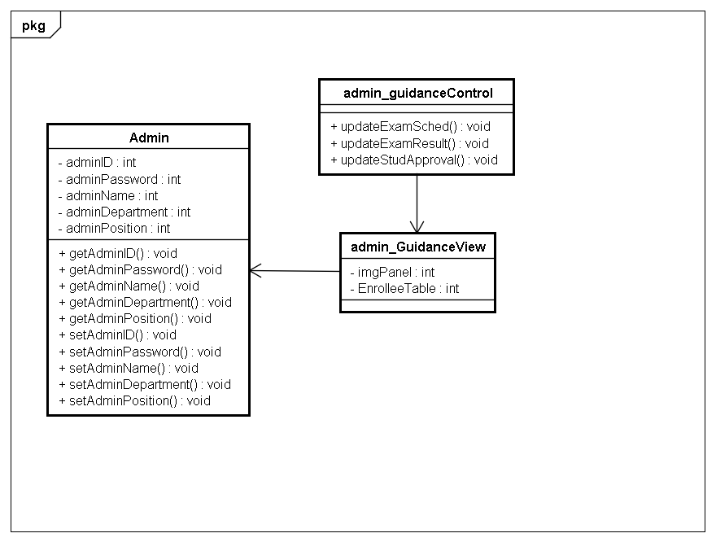

Student

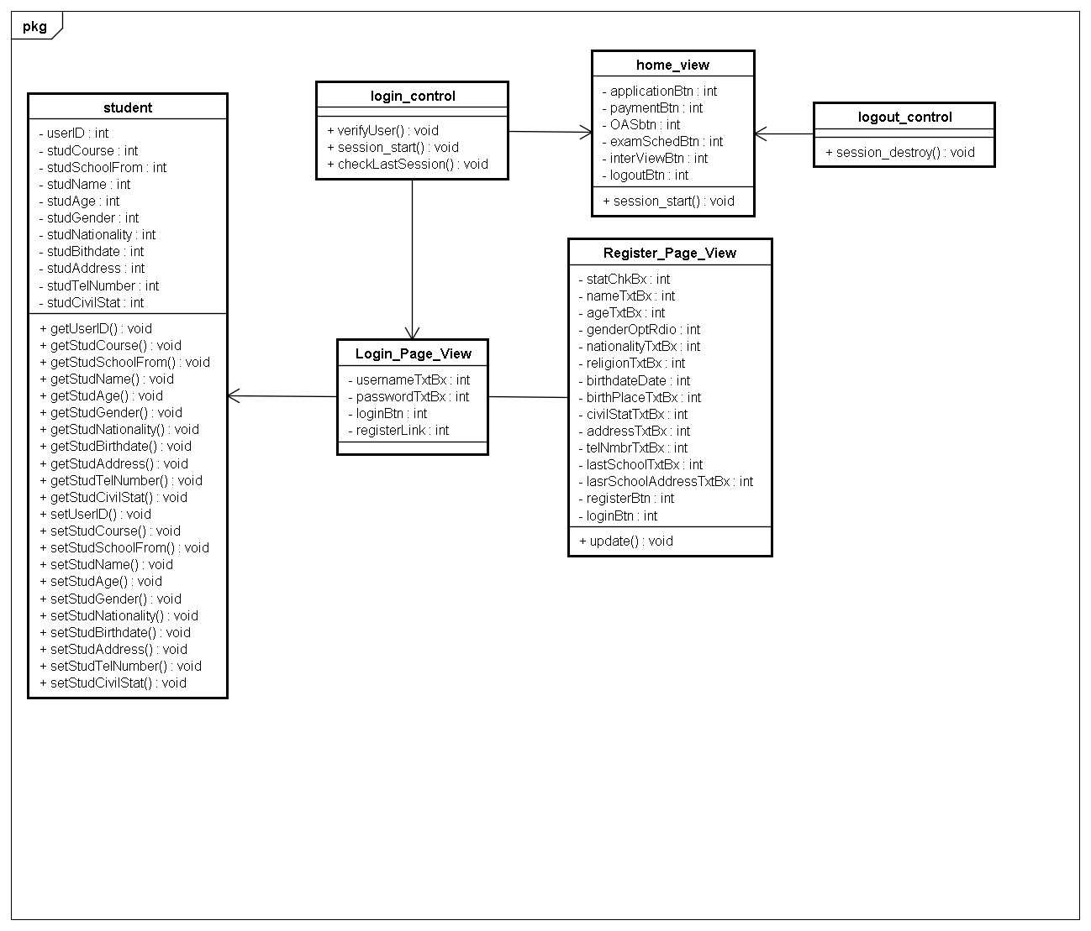Login/Logout Class Diagram

Student

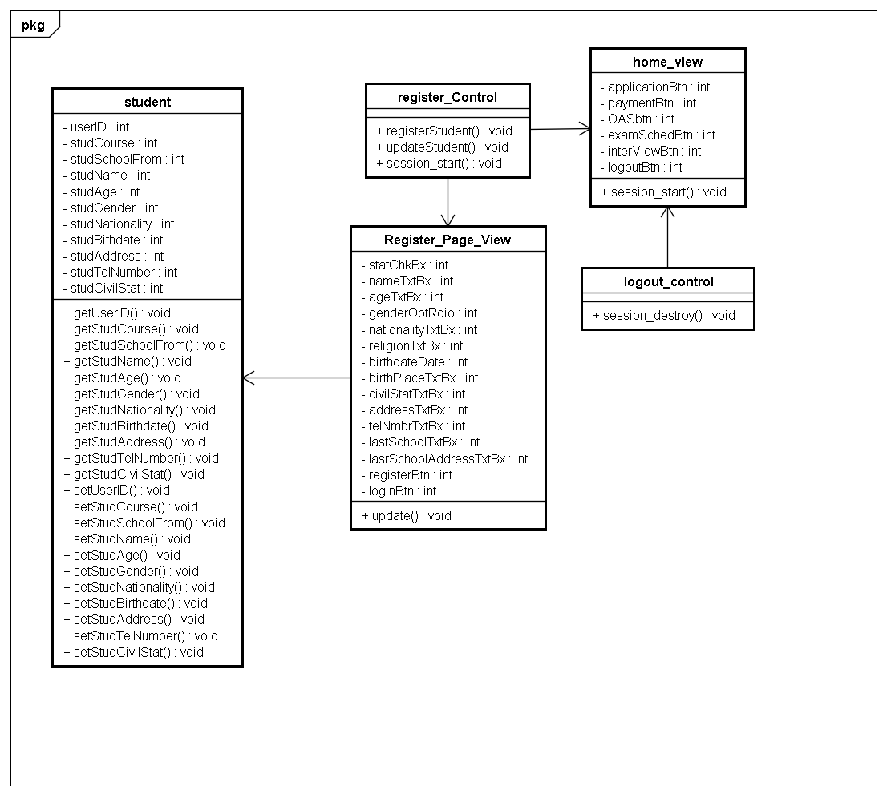Register Class Diagram

Student

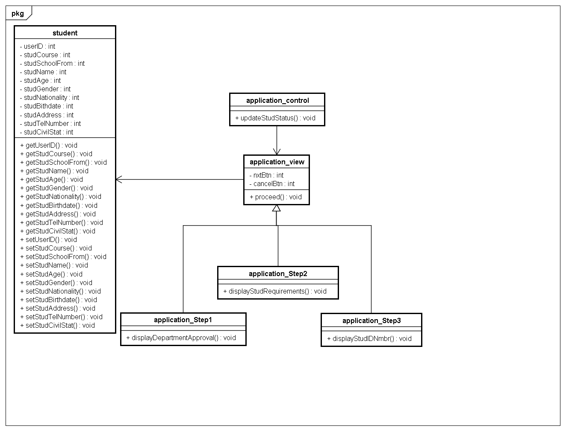Application Class Diagram

Student

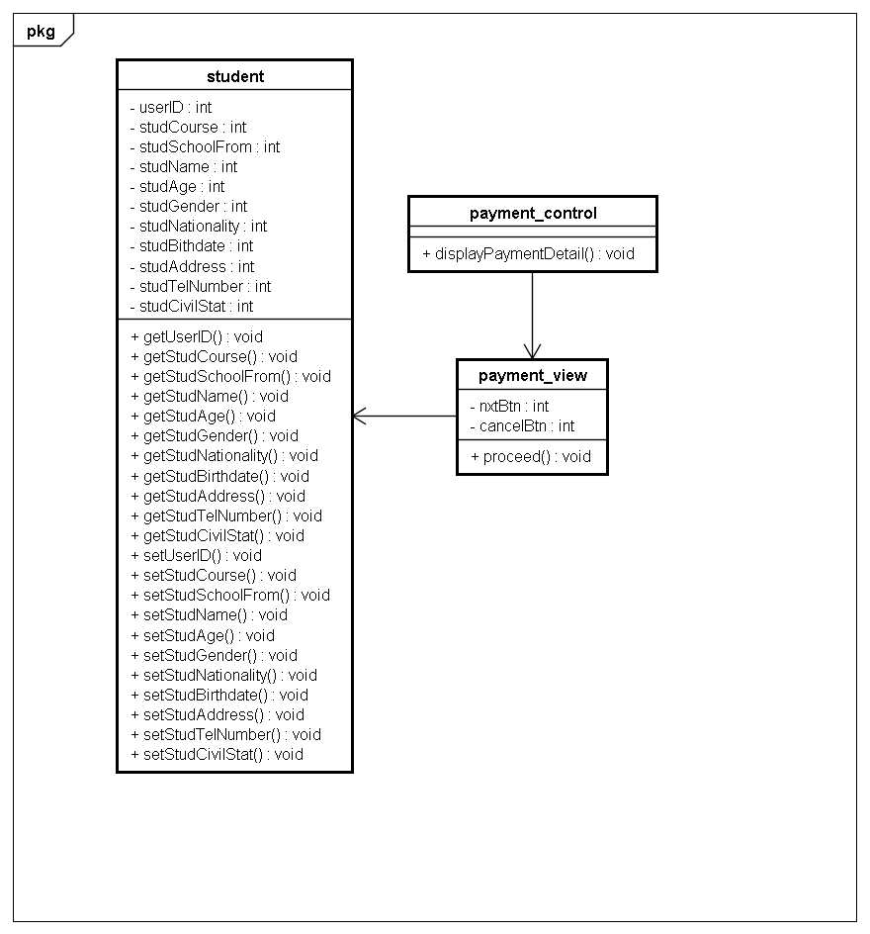Payment Class Diagram

Student

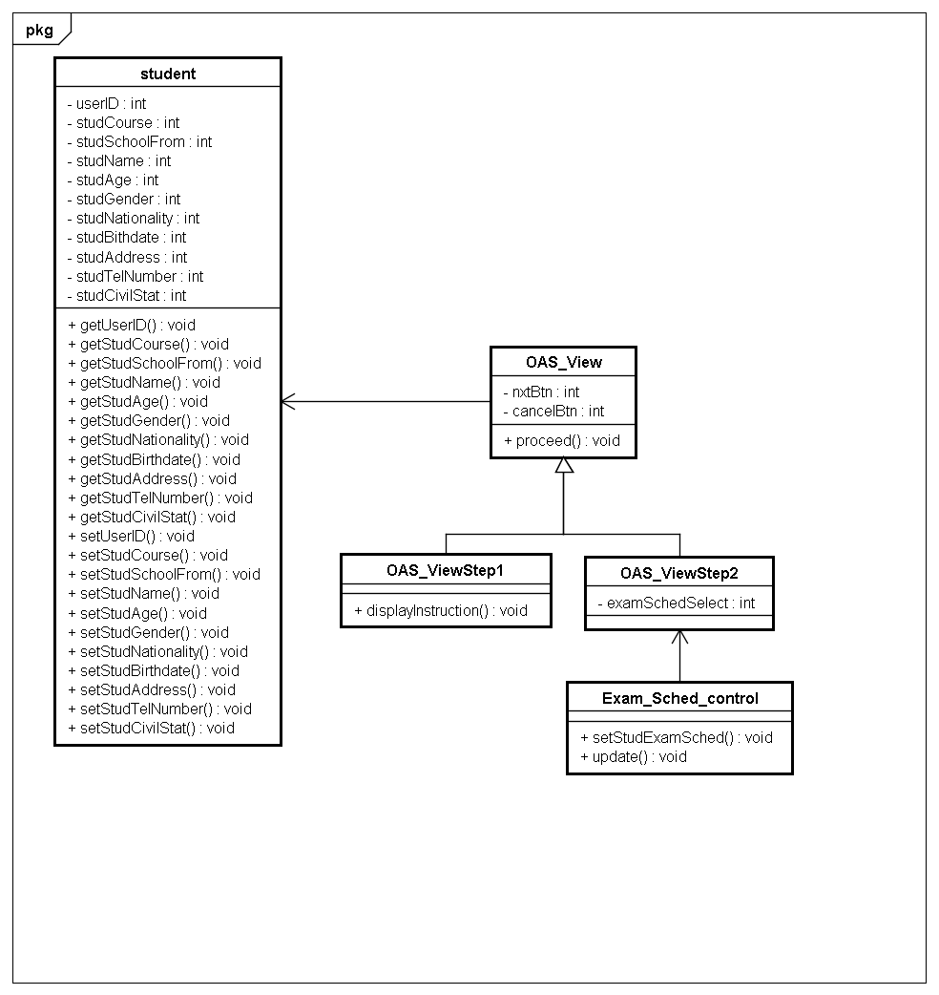OAS Class Diagram

Student

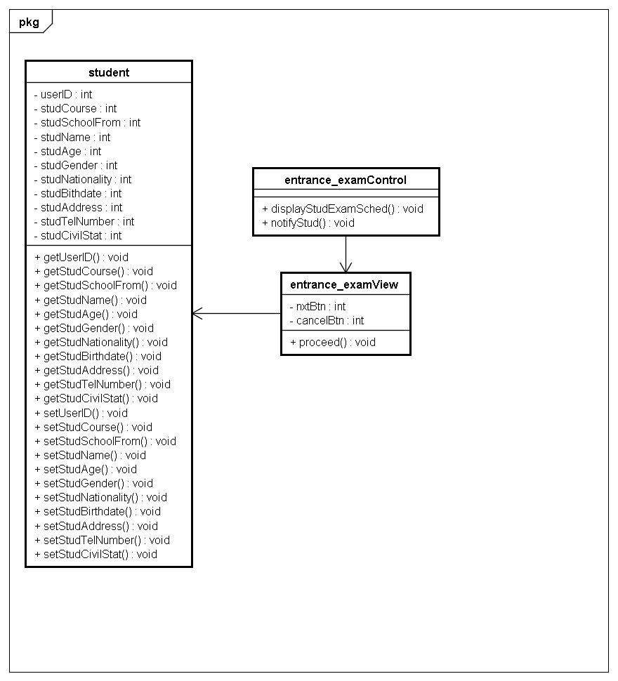Entrance Exam Class Diagram

Student

Interview Class Diagram

